Group Membership Instructions

Please note: The group member who fills out the group membership application becomes the "administrator" for the group and will be able to add additional members, transfer memberships and renew the membership Please make sure the administrator of the group is aware of the role.
- The membership application form can be found under the “Join Us” menu, submenu “Group Membership Application”.
- The application will only be populated with the administrator information. When complete the administrator will receive an email with login information to the astdsac.org website.
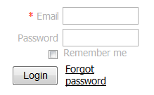
- Once the payment is paid in full then the administrator will login to the website and click on view profile in the upper right hand corner.
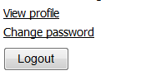
- On the profile page, under the “Bundle summary” section click on “Add member”.
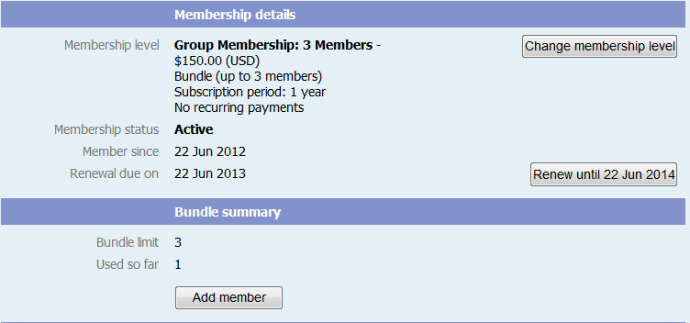
- You will be routed to the application form for individual members, but only need to fill out minimal information for the group members.
Note: You must include the Email address even though the field is not mandatory.
- The additional group members may login later to view their profiles and update with specific information if desired.

Questions: Don’t hesitate to email us at mail@astdsac.org or call the phone number on the home page.

